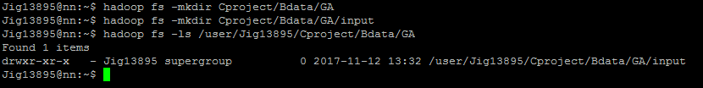

--move the input file into Hdfs path

hadoop fs -put /home/data/CampaignData_full.csv hdfs://nn.cdh2017.com:8020/user/Jig13895/Cproject/Bdata/GA/input;



register '/home/data/piggybank.jar';

define CSVLoader org.pig.piggybank.storage.CSVLoader();

